27 Poplar Street

Yonkers, New York 10701

Tel. 914 376-8460

Fax 914 376-8468

mametrano@yonkerspublicschools.org

**Dr. Edwin M. Quezada**

Superintendent of Schools

**Dr. Andrea S. Coddett**

Assistant Superintendent

Elementary Education

**Mark Ametrano**

Principal

September 8, 2020

Dear Enrico Fermi families in grades K-8,

We hope this message finds you and your family well. Below, please find the procedure for families to come to the school in an organized, safe manner to pick up consumable instructional materials which students will need for this month of 100% remote learning. Please refer to the schedule below for **September 10th** to obtain the time that each family can pick up their child’s instructional materials.

The purpose of this schedule is to distribute materials swiftly and safely. The staff at Enrico Fermi expects that families who wish to pick up materials will respect all traffic, health and safety precautions that are in place. Parents must adhere to the designated times in the schedule. **No visitors will be permitted to enter classrooms for any reason**.

|  |  |  |
| --- | --- | --- |
| Last Name of STUDENT | Date | Time |
| A-H | Thursday, September 10th | 9:30am- 12:00pm |
| I-P | Thursday, September 10th | 1:00am-3:00pm |
| Q-Z | Friday, September 11th | 9:30am- 12:00pm |
| **A-Z** | **Friday, September 11th** | **1pm- 3pm (Make-up)** |

**Kindergarten -- 2nd grade** can pick up materials from the **Main entrance**.

**Grades 6—8**can pick up materials from **Oak street entrance**.

**Grades 3 – 5th** can pick up materials from the **Oak street garage**.

***Parents will need to give the name, grade and teacher of their child/children in K-8.***

Please keep in mind you will need to follow these rules:

|  |
| --- |
| * ***Please follow school personnel’s instructions*** * ***Please be patient*** * ***No one will be permitted inside classrooms*** * ***Please leave the property immediately after picking up materials to ensure the social distancing is maintained***. |

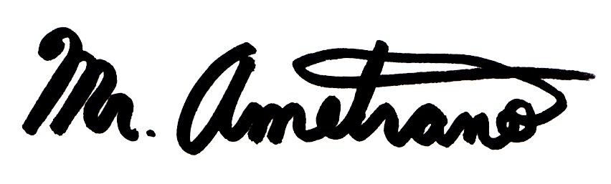

Mr. Mark Ametrano

